SickOS 1.1
- Firstly, nmap/netdiscover is used to locate the target IP
- Nmap sends packets to each IP specified, netdiscover uses ARP requests to locate hosts
- Three ports were open, including a http-proxy (3128) and an http (8080)
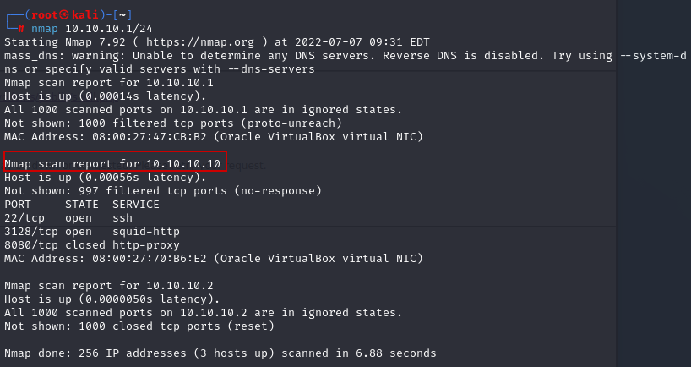
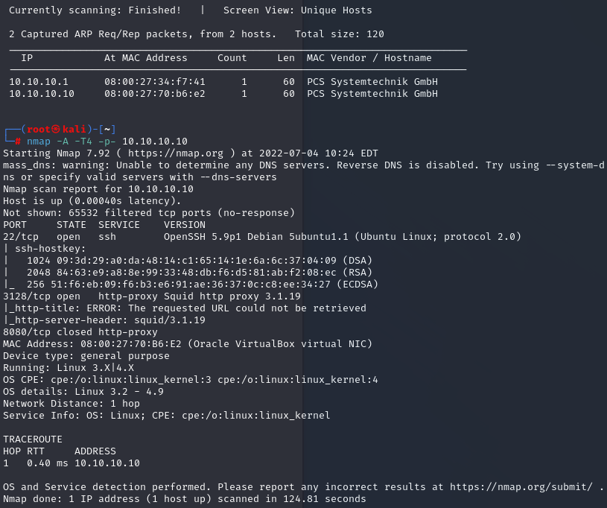
- In order to check the IP, in a web browser the proxy port was configured to be able to search for 10.10.10.10
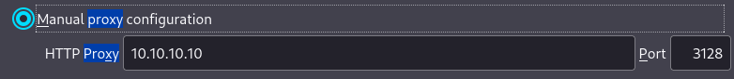

- We are presented with this webpage
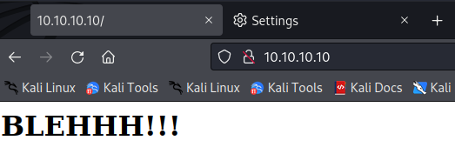

- Checking the robots.txt we see this web server might be running wolfcms
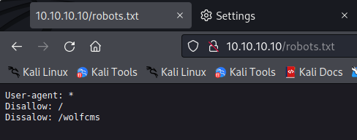
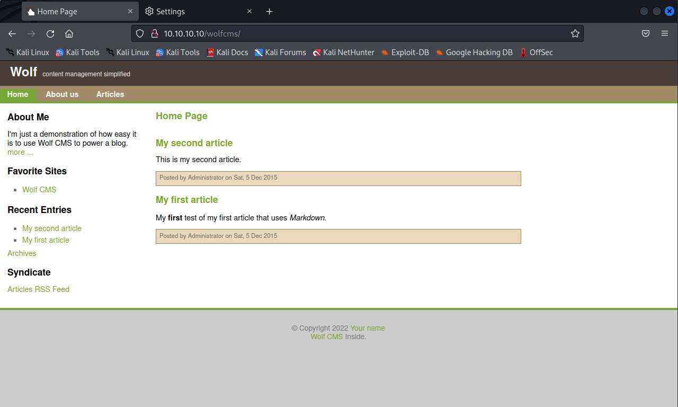
- Using Dirb, /docs/ and /public/ directories are found
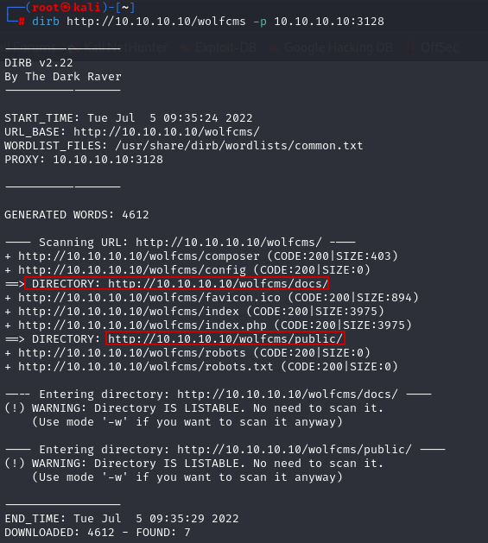
- Checking those two directories, we find a place where a reverse php shell can be uploaded
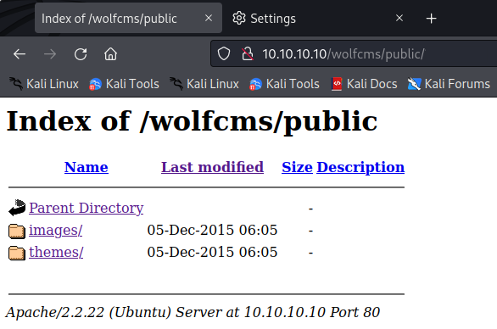

- And a place where it confirms there is an admin login and default creds we once used
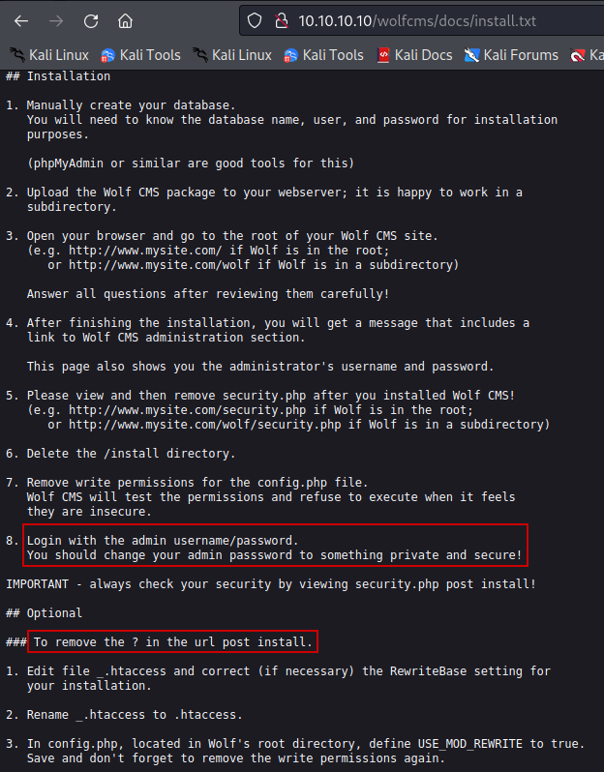

- Researching wolfcms, the admin page can be located at /admin/ but this did not work
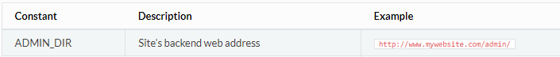
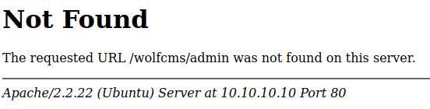

- But using /?/admin/ I was redirected to /?/admin/login
- While cycling through admin credentials, username/password admin/admin allowed access
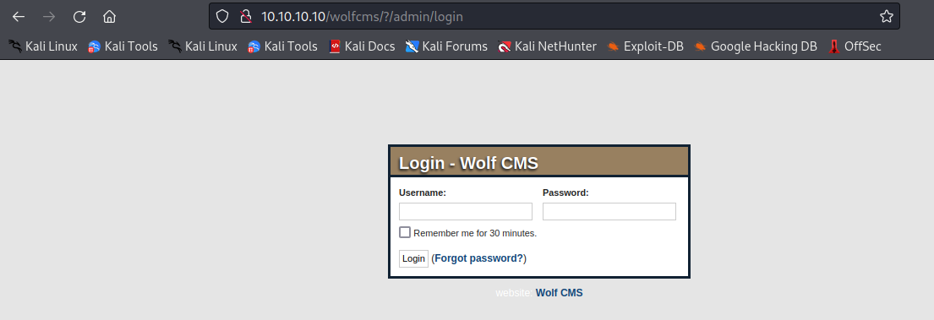
- From there, the reverse shell php file was uploaded (via: php-reverse-shell | pentestmonkey)
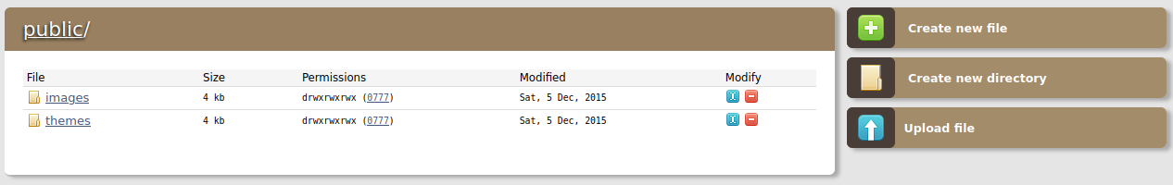
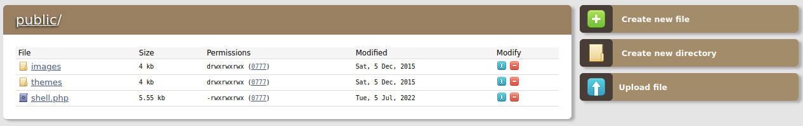

- On port 4444 a listener is set up in order to “catch” the shell
- Once that is running, click on the shell file uploaded on /public/ this should initiate the reverse shell
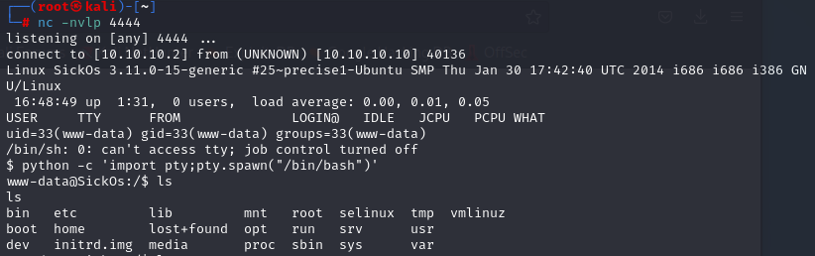

- Check the /etc/passwd file to check for any users
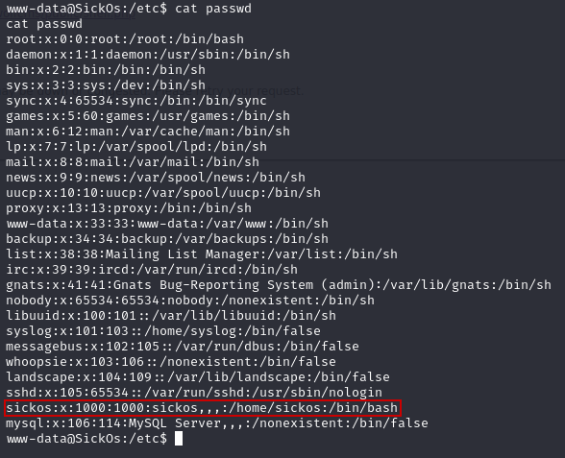

- While checking the /var/www directory, /wolfcms was found which contained the config.php
- Further exploration finds the database root username and password is given
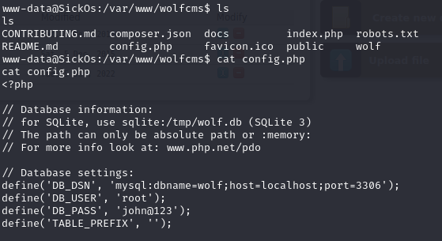

- Using these credentials grants root access
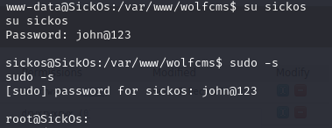

- Here the root flag can be found
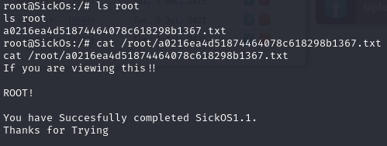

- In order to get the file on my system, I move the flag to the var/www/wolfcms/public directory where I uploaded the reverse shell beforehand
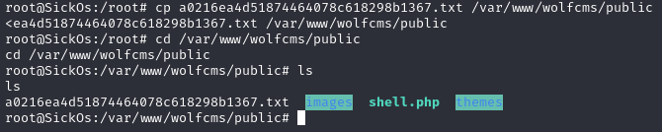
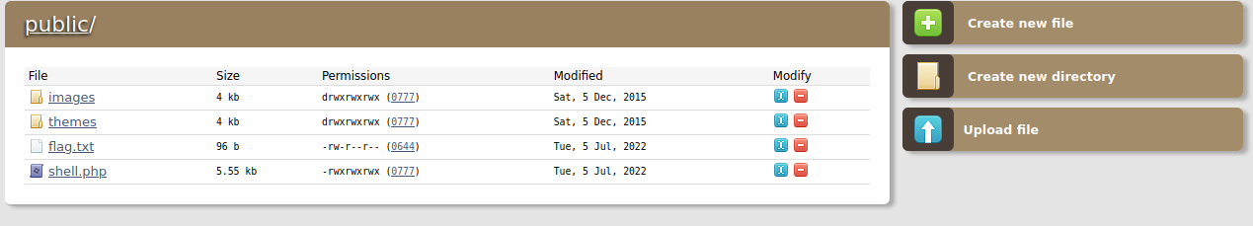

- Using wget, I download the flag file by specifying the path
- After checking the file on my machine, it was a success
